# 

**THYROID DETECTION**

Wireframe Document

**Domain : Machine Learning**

**Creator : Lalatendu Dalai**

**Date : 27.12.2023**

**Abstract**

The Thyroid gland is a vascular gland and one of the most important organs of a human body. This gland secretes two hormones which help in controlling the metabolism of the body. The two types of Thyroid disorders are Hyperthyroidism and Hypothroidism. The main goal of this project is to build a prediction model using multi machine learning tecniques which will predict the estimated risk on a patient’s chance of obtaining thyroid disease or not.

.

**Sign in page**

The user must sign in to the Airflow sign in page with user name “admin” and password “admin”. 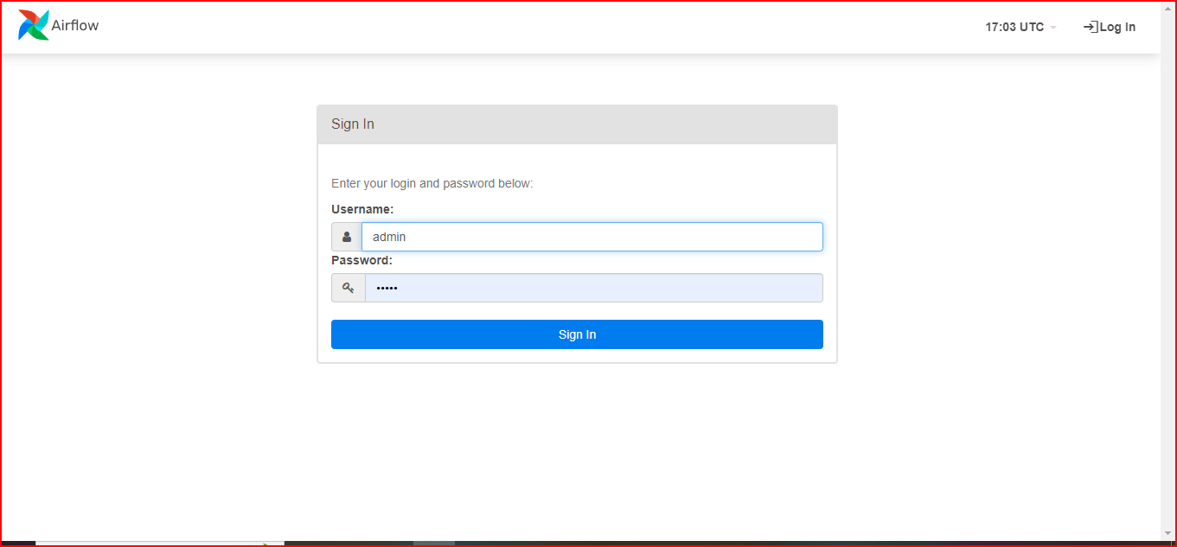

**Home page**

Click on “thyroid_detection_training”

Application page

